

HADOOP ASSIGNMENT-1



A.joshi sataya vardan

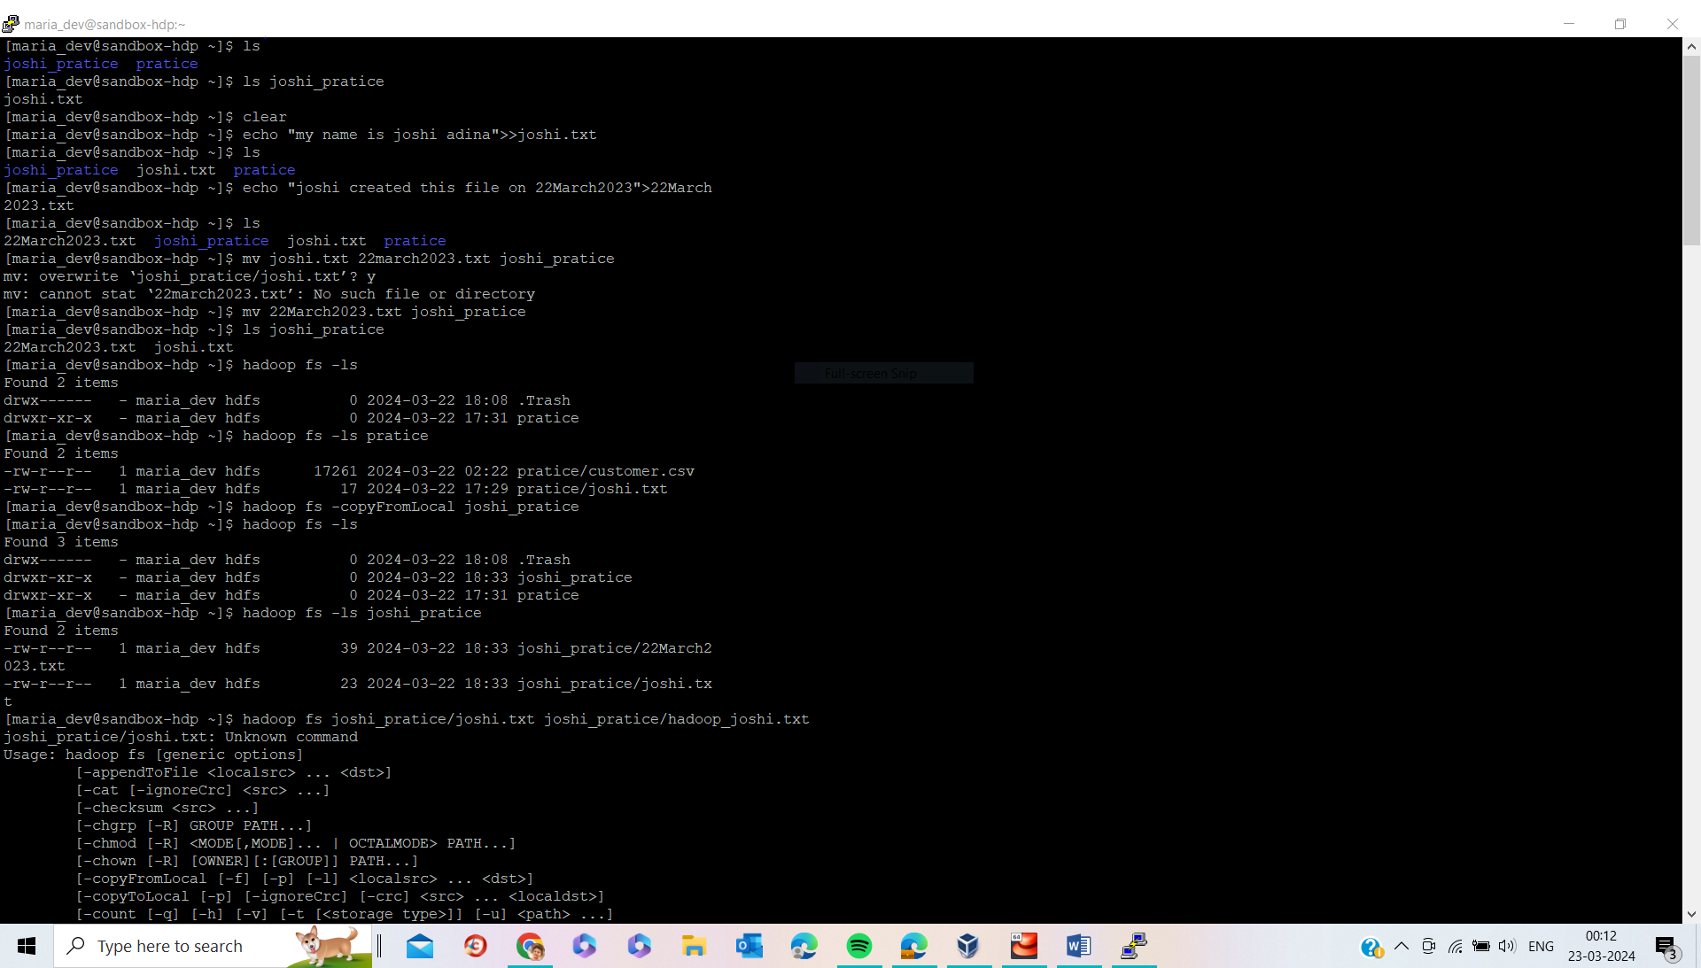

* First list out the folders in root location of local machine by using this command “**ls**”.
* I created directory with name “**joshi_pratice**” by using “**mkdir <foldername>**” .
* I create new file name “**joshi.txt**” and “**22March2023.txt**” by using “ **echo “ ” >> <filename.extension>”** in local root directory.
* Move files from local root location into **“joshi_pratice”** directory by using “**mv <filename> <path/location>**”.
* By using “**hadoop fs -ls**” command we get to know how many folders are there in root location of Hadoop.
* Create one directory in Hadoop file system with name “**joshi_pratice**” by using command “**hadoop fs –mkdir joshi_pratice**”
* Move all these files or folder from local to Hadoop by using this command “**Hadoop fs –copyFromLocal joshi_pratice**”
* Check files are appear into Hadoop file system successfully are not by using this command “**hadoop fs –ls joshi_pratice**”

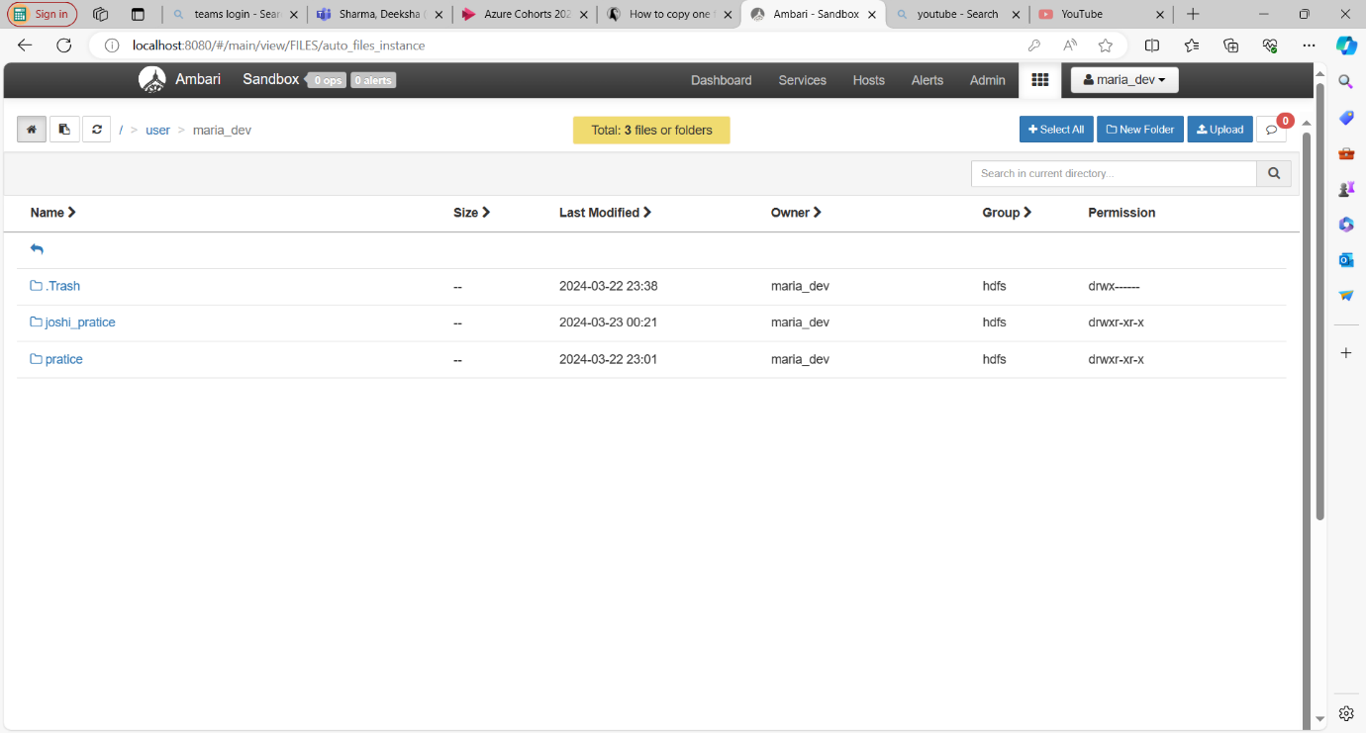

We can see that folder “**joshi_pratice**” which is copied folder from local to Hadoop in above pic which is take from Ambary site which is a Graphical user interface for Hadoop.

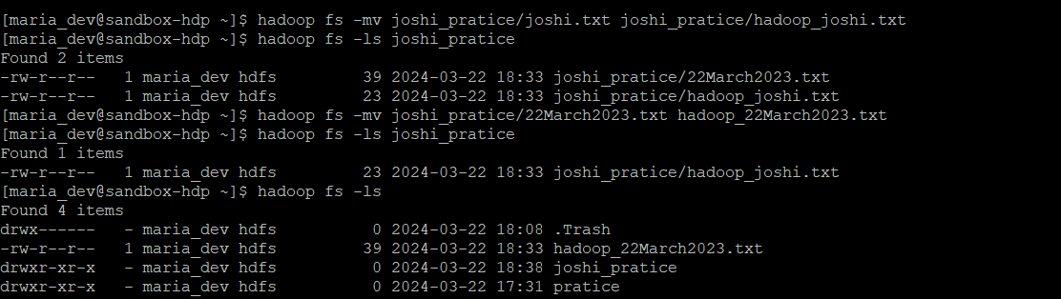

Rename files “ **joshi.txt** ” to “ **hadoop_joshi.txt** ”,” **22March2023** ” to “ **hadoop_22March2023** ” by using command “ **hadoop fs –mv <oldfilename> <newfilename>** ”.

* 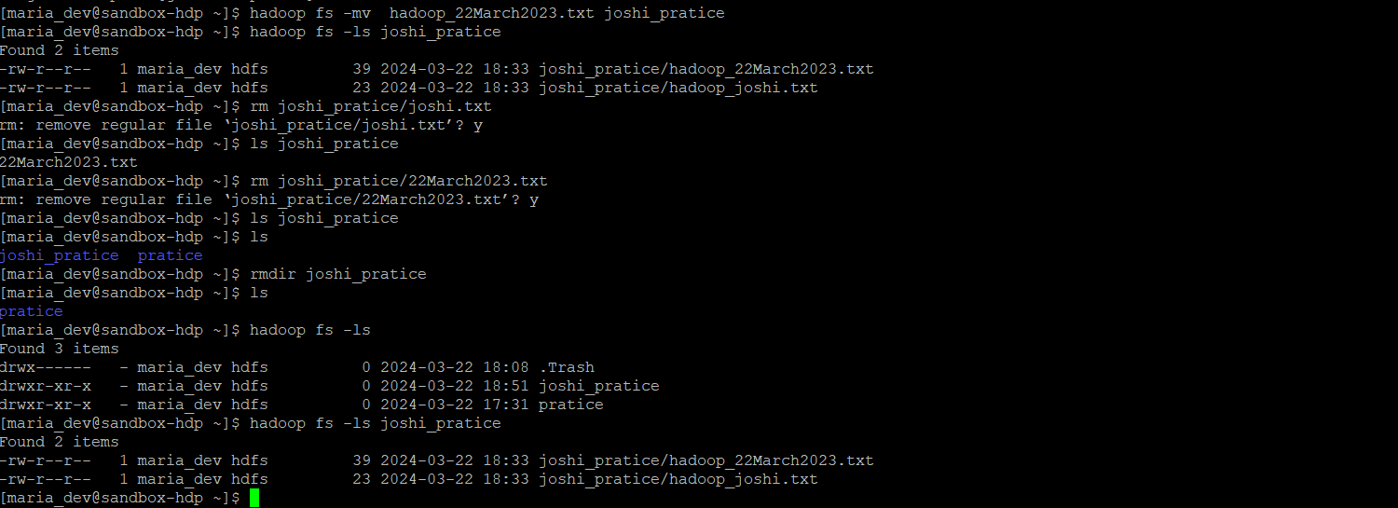check whether name of files got renamed are not by using this command “**hadoop fs –ls joshi_pratice**” which list files in joshi_pratice folder in Hadoop file system.
* Remove files in local host by “Joshi.txt” ,”22March2023.txt” by using this command “**rm <filename>**”.
* Remove directory “**joshi_pratice** ” in local host by using this command “**rmdir <directoryname>”** .

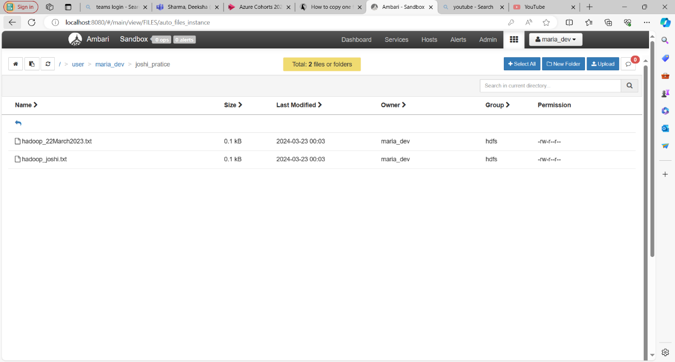

Above picture will shows Files inside folder “ **joshi_pratice** ” in Hadoop file system

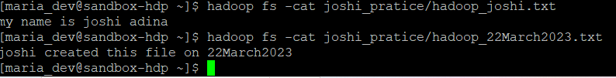

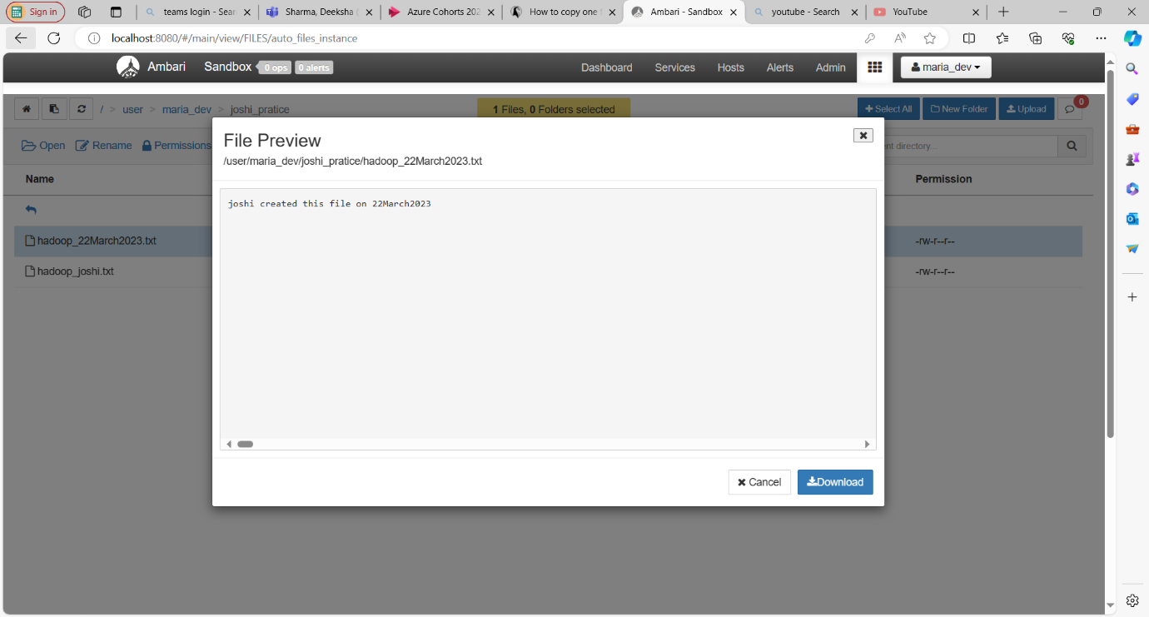Content in the files can be seen by using this command **“hadoop fs –cat <filename>”.**

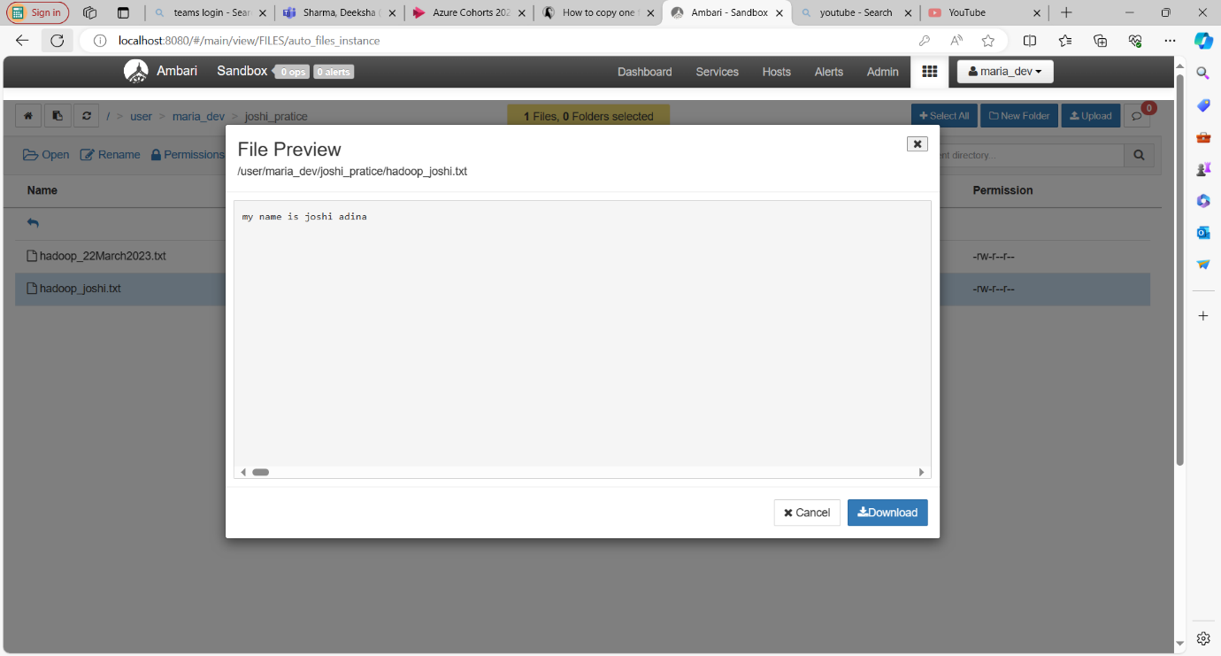Above pic shows content inside the “Hadoop_22March2023.txt”

Above pic shows content inside the “Hadoop_joshi.txt”